Right Hexagonal Pyramid
# Source: AI Source: Provided by: [Data Path: Persons Table -> ID Column: 1, Name_En Column: Motasem Essam] -> From: [ChatGPT] on [7/25/2026]
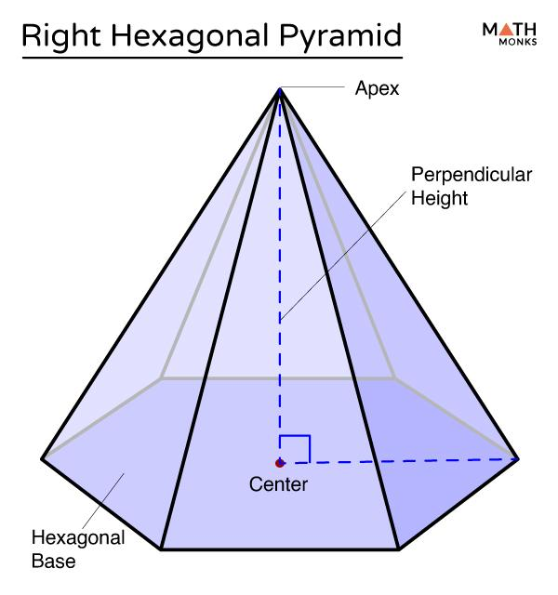
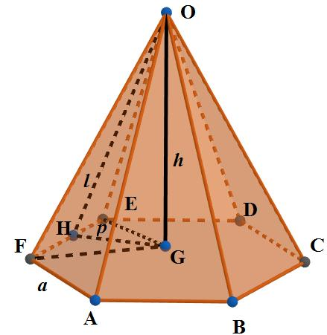
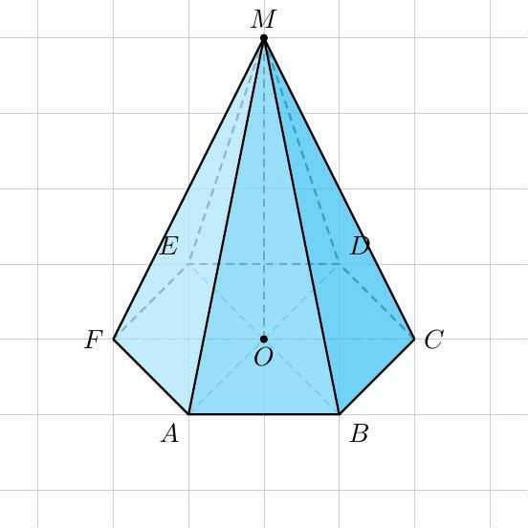

Definition
# Source: AI Source: Provided by: [Data Path: Persons Table -> ID Column: 1, Name_En Column: Motasem Essam] -> From: [ChatGPT] on [7/25/2026]
A right hexagonal pyramid is a three-dimensional geometric solid with a hexagonal base and six triangular lateral faces that meet at a single point called the apex. It is right when the perpendicular from the apex to the base plane meets the base at its designated center.
The base may be regular or irregular, provided its center is clearly defined. When the base is a regular hexagon, the apex lies directly above the hexagon's center, and all six lateral edges are equal. In that case, the pyramid is also a regular hexagonal pyramid under the standard definition.

Simple Definition
# Source: AI Source: Provided by: [Data Path: Persons Table -> ID Column: 1, Name_En Column: Motasem Essam] -> From: [ChatGPT] on [7/25/2026]
A right hexagonal pyramid is a pyramid with a six-sided base and an apex directly above the center of the base, so its height is perpendicular to the base.

Key Characteristics
# Source: AI Source: Provided by: [Data Path: Persons Table -> ID Column: 1, Name_En Column: Motasem Essam] -> From: [ChatGPT] on [7/25/2026]
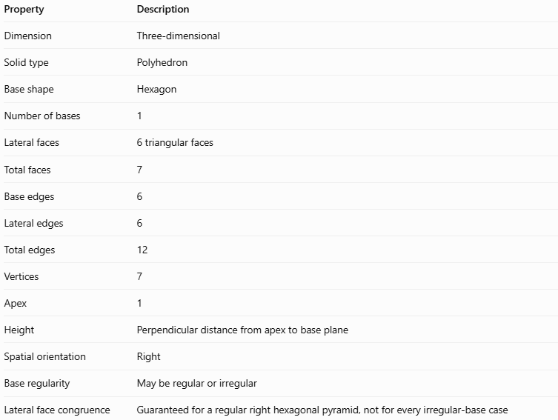
Property | Description
Dimension | Three-dimensional
Solid type | Polyhedron
Base shape | Hexagon
Number of bases | 1
Lateral faces | 6 triangular faces
Total faces | 7
Base edges | 6
Lateral edges | 6
Total edges | 12
Vertices | 7
Apex | 1
Height | Perpendicular distance from apex to base plane
Spatial orientation | Right
Base regularity | May be regular or irregular
Lateral face congruence | Guaranteed for a regular right hexagonal pyramid, not for every irregular-base case

Geometric Representation
# Source: AI Source: Provided by: [Data Path: Persons Table -> ID Column: 1, Name_En Column: Motasem Essam] -> From: [ChatGPT] on [7/25/2026]
The main components are:
- Hexagonal base: The six-sided polygon forming the bottom of the pyramid.
- Apex: The point where all six lateral triangular faces meet.
- Base edges: The six sides of the hexagonal base.
- Lateral edges: The six segments connecting the apex to the base vertices.
- Lateral faces: The six triangles connecting the apex to the six base edges.
- Height ($h$): The perpendicular distance from the apex to the base plane.
- Base center: The designated center of the hexagon, directly below the apex.
- Slant height ($l$): For a regular right hexagonal pyramid, the perpendicular distance along a lateral face from the apex to the midpoint of a base edge.
For an irregular base, the lateral faces and their slant heights may differ. The right-pyramid condition concerns the apex's position relative to the base center, not the equality of the triangular faces.

Mathematical Representations and Formulas
# Source: AI Source: Provided by: [Data Path: Persons Table -> ID Column: 1, Name_En Column: Motasem Essam] -> From: [ChatGPT] on [7/25/2026]
Let:
- $s_{i}$ = length of the $i$-th base edge
- $p$ = base perimeter
- $B$ = base area
- $h$ = perpendicular height
- $A_{L}$ = lateral surface area
- $A_{T}$ = total surface area
- $V$ = volume

A. Base perimeter
# Source: AI Source: Provided by: [Data Path: Persons Table -> ID Column: 1, Name_En Column: Motasem Essam] -> From: [ChatGPT] on [7/25/2026]
For a hexagonal base with six side lengths:
$$\boxed{p=\sum_{i=1}^{6}{s_{i}}}$$
For a regular hexagon with side length $a$:
$$\boxed{p=6a}$$

B. Base area
# Source: AI Source: Provided by: [Data Path: Persons Table -> ID Column: 1, Name_En Column: Motasem Essam] -> From: [ChatGPT] on [7/25/2026]
For a general hexagonal base, calculate the area from its dimensions or by dividing it into simpler shapes.
For a regular hexagon:
$$\boxed{B=\frac{3\sqrt{3}}{2}a^{2}}$$

C. Volume
# Source: AI Source: Provided by: [Data Path: Persons Table -> ID Column: 1, Name_En Column: Motasem Essam] -> From: [ChatGPT] on [7/25/2026]
The volume formula applies to both right and oblique hexagonal pyramids:
$$\boxed{V=\frac{1}{3}Bh}$$
For a regular hexagonal base:
$$\boxed{V=\frac{\sqrt{3}}{2}a^{2}h}$$

D. Lateral surface area
# Source: AI Source: Provided by: [Data Path: Persons Table -> ID Column: 1, Name_En Column: Motasem Essam] -> From: [ChatGPT] on [7/25/2026]
For any hexagonal pyramid, the lateral surface area is the sum of its six triangular faces:
$$\boxed{A_{L}=\sum_{i=1}^{6}{A_{i}}}$$
If the base-edge length and the perpendicular altitude of each lateral face are $s_{i}$ and $l_{i}$, respectively:
$$\boxed{A_{L}=\frac{1}{2}\sum_{i=1}^{6}{s_{i}}l_{i}}$$
For a regular right hexagonal pyramid, all six lateral faces are congruent, so the formula simplifies to:
$$\boxed{A_{L}=\frac{1}{2}pl=3al}$$

E. Total surface area
# Source: AI Source: Provided by: [Data Path: Persons Table -> ID Column: 1, Name_En Column: Motasem Essam] -> From: [ChatGPT] on [7/25/2026]
$$\boxed{A_{T}=B+A_{L}}$$
For a regular right hexagonal pyramid:
$$\boxed{A_{T}=\frac{3\sqrt{3}}{2}a^{2}+3al}$$
F. Slant height for a regular right hexagonal pyramid
The base apothem is:
$$r=\frac{\sqrt{3}}{2}a$$
The perpendicular height, base apothem, and slant height form a right triangle:
$$l=\sqrt{h^{2}+r^{2}}$$
Therefore:
$$\boxed{l=\sqrt{h^{2}+{\frac{3}{4}a}^{2}}}$$
These simplified slant-height and surface-area formulas assume a regular hexagonal base and a centered apex.

Worked Examples
# Source: AI Source: Provided by: [Data Path: Persons Table -> ID Column: 1, Name_En Column: Motasem Essam] -> From: [ChatGPT] on [7/25/2026]
Example 1: Counting faces, edges, and vertices
A right hexagonal pyramid has a six-sided base.
- Faces: $6+1=7$
- Edges: $6+6=12$
- Vertices: $6+1=7$
Euler's formula verifies the result:
$$V_{e}-E+F=7-12+7=2$$
Example 2: Calculating the volume
Suppose a right hexagonal pyramid has a base area of $72{\text{ cm}}^{2}$ and a perpendicular height of $10\text{ cm}$.
$$V=\frac{1}{3}Bh$$
$$V=\frac{1}{3}\left(72\right)\left(10\right)$$
$$\boxed{V=240{\text{ cm}}^{3}}$$
This formula works whether the base is regular or irregular.
Example 3: Calculating surface area
Suppose a regular right hexagonal pyramid has a base side length of $4\text{ cm}$ and a perpendicular height of $6\text{ cm}$.
Step 1 — Calculate the base area
$$B=\frac{3\sqrt{3}}{2}{\left(4\right)}^{2}$$
$$B=24\sqrt{3}≈41.57{\text{ cm}}^{2}$$
Step 2 — Calculate the base apothem
$$r=\frac{\sqrt{3}}{2}\left(4\right)=2\sqrt{3}\text{ cm}$$
Step 3 — Calculate the slant height
$$l=\sqrt{6^{2}+{\left(2\sqrt{3}\right)}^{2}}$$
$$l=\sqrt{48}=4\sqrt{3}≈6.93\text{ cm}$$
Step 4 — Calculate the lateral surface area
$$A_{L}=\frac{1}{2}\left(24\right)\left(4\sqrt{3}\right)$$
$$A_{L}=48\sqrt{3}≈83.14{\text{ cm}}^{2}$$
Step 5 — Calculate the total surface area
$$A_{T}=24\sqrt{3}+48\sqrt{3}$$
$$\boxed{A_{T}=72\sqrt{3}≈124.71{\text{ cm}}^{2}}$$

Comparison with Related Concepts
# Source: AI Source: Provided by: [Data Path: Persons Table -> ID Column: 1, Name_En Column: Motasem Essam] -> From: [ChatGPT] on [7/25/2026]
Right Hexagonal Pyramid
The apex lies above the designated center of the hexagonal base. The base may be regular or irregular.
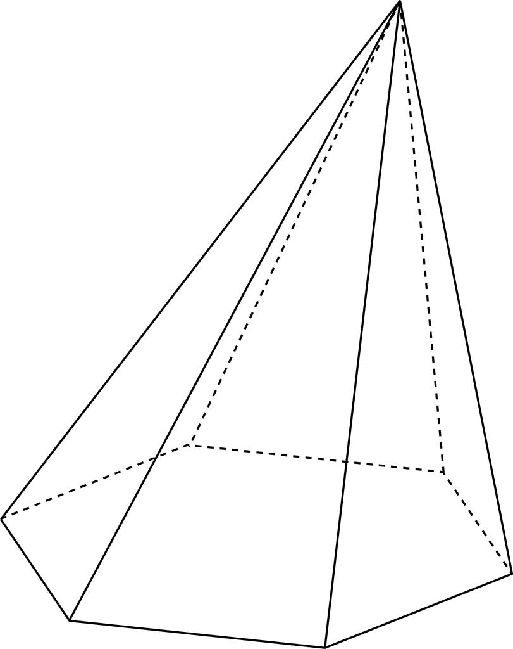
Oblique Hexagonal Pyramid
The apex is offset from the designated base center, producing an inclined pyramid.
Regular Hexagonal Pyramid
Has a regular hexagonal base and a centered apex. Its six lateral faces are congruent isosceles triangles.
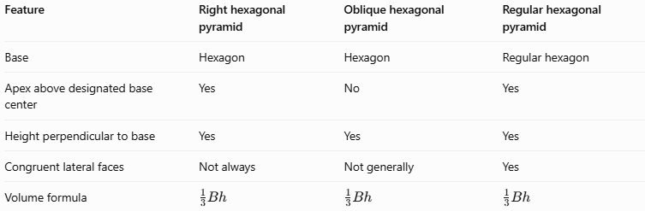
Feature | Right hexagonal pyramid | Oblique hexagonal pyramid | Regular hexagonal pyramid
Base | Hexagon | Hexagon | Regular hexagon
Apex above designated base center | Yes | No | Yes
Height perpendicular to base | Yes | Yes | Yes
Congruent lateral faces | Not always | Not generally | Yes
Volume formula | $$\frac{1}{3}Bh$$ | $$\frac{1}{3}Bh$$ | $$\frac{1}{3}Bh$$
A regular hexagonal pyramid is a special case of a right hexagonal pyramid. A right hexagonal pyramid with an irregular base is not necessarily a regular pyramid.

Applications
# Source: AI Source: Provided by: [Data Path: Persons Table -> ID Column: 1, Name_En Column: Motasem Essam] -> From: [ChatGPT] on [7/25/2026]
- Architecture: Pyramid-shaped roof features and decorative structures.
- Packaging: Hexagonal containers with tapered tops.
- Engineering and design: Modeling components with six-sided bases and centered apexes.
- Computer graphics: Creating symmetrical 3D polygon-based models.
- Mathematics education: Studying perpendicular height, slant height, volume, and surface area.

Key Points
# Source: AI Source: Provided by: [Data Path: Persons Table -> ID Column: 1, Name_En Column: Motasem Essam] -> From: [ChatGPT] on [7/25/2026]
- A right hexagonal pyramid has 7 faces, 12 edges, and 7 vertices.
- It has one hexagonal base and six triangular lateral faces.
- Its apex lies above the designated center of the base.
- Its height is perpendicular to the base plane.
- Its base may be regular or irregular.
- Its volume is $V=\frac{1}{3}Bh$.
- For a regular right hexagonal pyramid, the lateral surface area is $A_{L}=\frac{1}{2}pl$.
- The simplified regular-pyramid formulas should not be applied automatically to an irregular base.

Conclusion
# Source: AI Source: Provided by: [Data Path: Persons Table -> ID Column: 1, Name_En Column: Motasem Essam] -> From: [ChatGPT] on [7/25/2026]
A right hexagonal pyramid is a polyhedron with a six-sided base and six triangular lateral faces meeting at an apex positioned above the designated center of the base. Its right orientation determines the relationship between the apex and the base, while the regularity of the base determines whether the lateral faces are congruent. Correctly distinguishing these properties makes it easier to classify the solid and calculate its volume and surface areas.

